Image | 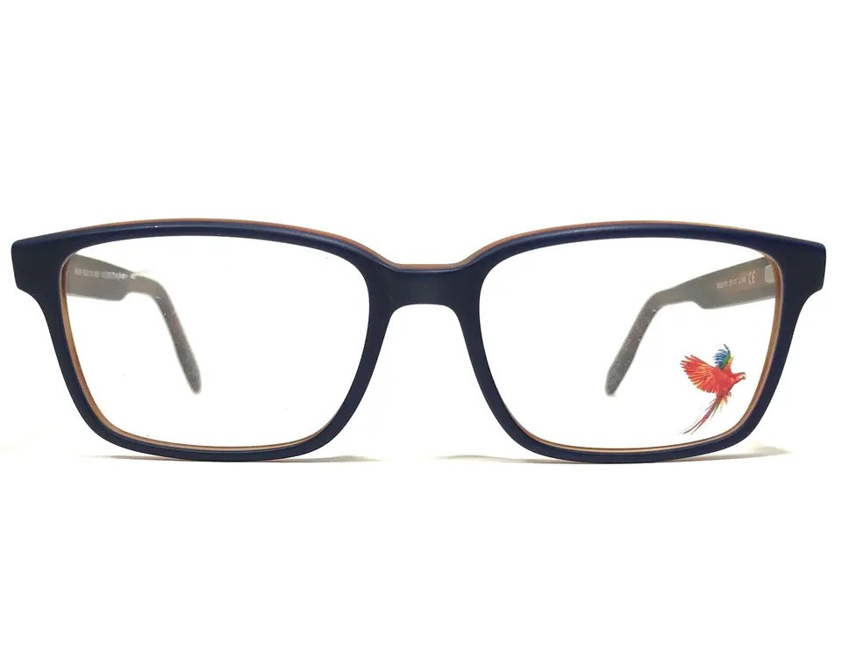
Brand | TIFFANY & CO.
Model Name | MJ 02115
Price | RS 1800
PRODUCT DETAILS

